A000-Afr-Ghana-Ashante-Gold dust container-19th c

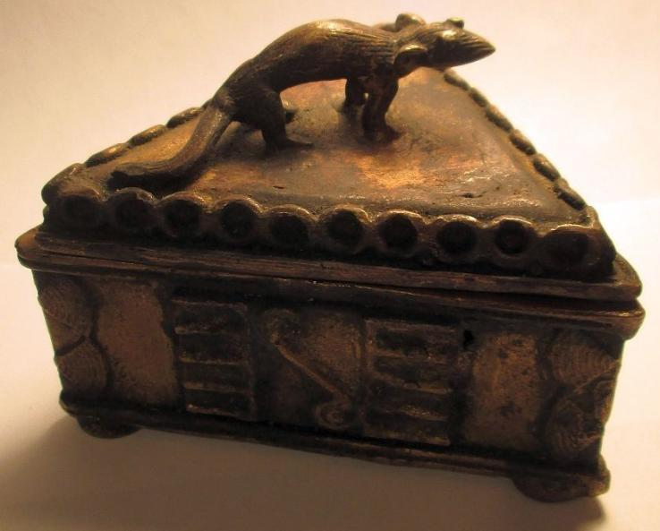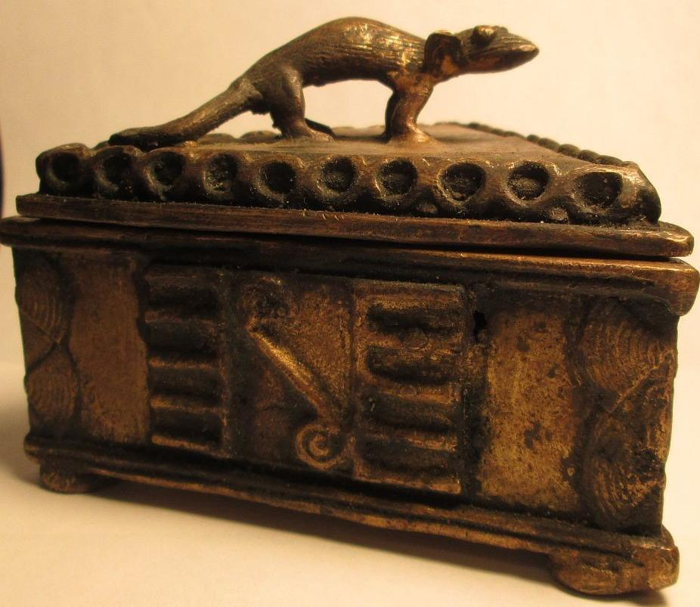

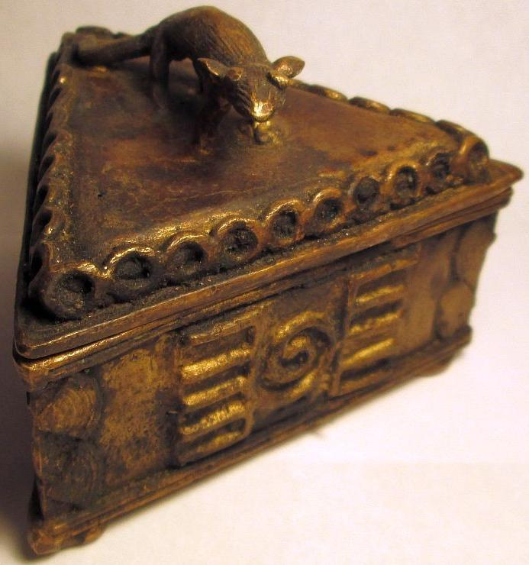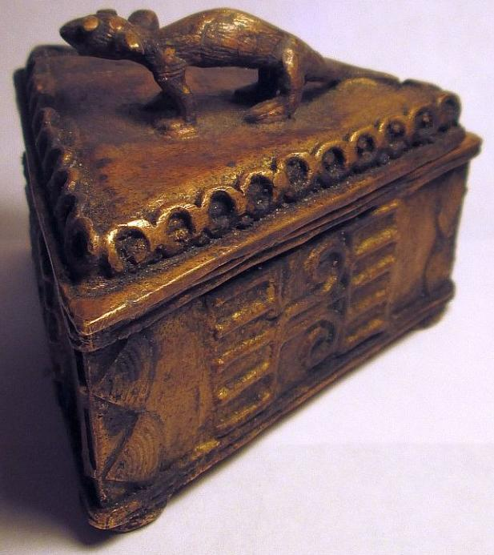

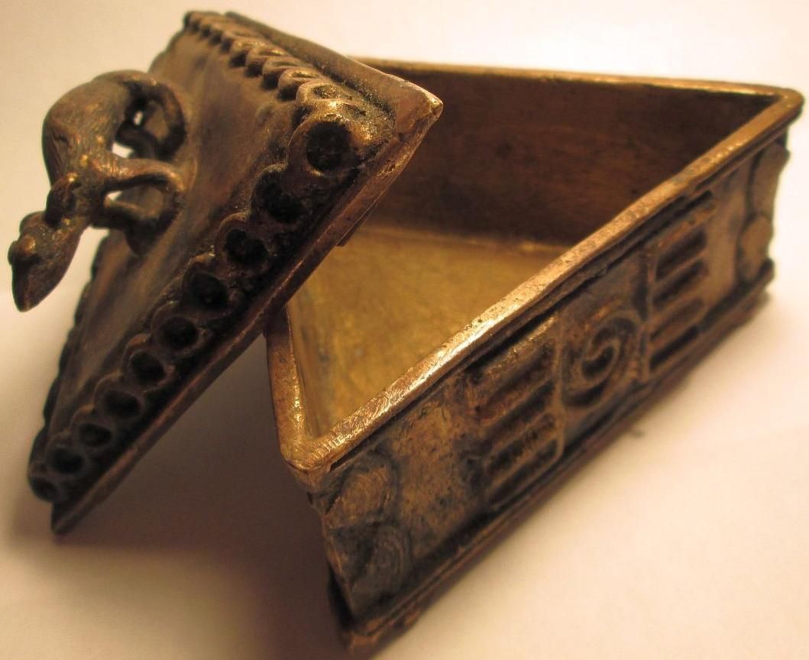

Figs. 1-5. A000-Afr-Ghana-Ashante-Gold dust container-19th c

Case No.: 6

**Accession No.**

**Formal Label:** Afr-Ghana-Ashante-Gold dust container-19th c

**Display Description:**

Ashanti bronze lost wax gold dust triangular container, Kuduo, measuring 4 x 3 inches, from the Ashante near Kumasi in Ghana, West Africa.

The animal finial which acts as a handle, was meant to be an apotropaic symbol to protect the contents of the container from unauthorized intruders. The symbols that are placed on the three sides of the container signify its use.

Kuduo were created to store valuable possessions such as gold dust, and served the symbolic purpose of safeguarding their owners' kra, or life force. They played an important role in ceremonies intended to maintain the spiritual well-being of those who owned them. At life's end, kuduo were left at their owners' burial sites along with other personal possessions. If the kuduo belonged to a paramount chief, it would accompany his ceremonially blackened stool in a special room devoted to his spirit and memory. These are not trade art. They were never sold to the public. They would have either been brought back by a family member or by a missionary on a trip from there. These are very rare.

**LC Classification:**

**Date or Time Horizon: 19th c**

**Geographical Area:** from the Ashante near Kumasi in Ghana, West Africa.

**Map:**

**GPS coordinates:**

**Cultural Affiliation:**

**Medium: brass.** The brass (largely from a vigorous trade in European imports, as early as the later 15th century), was cast using the lost-wax method - the best way of preserving fine modeling and detail in the finished product, but in no way suited to "production-line" methods

**Dimensions:** 4 x 3 inches

**Weight:**

**Condition:**

**Provenance:** from the Ashante near Kumasi in Ghana, West Africa.

**Discussion:**

Since gold was always kept as dust (not as worked objects or as ingots with fixed values), scales and weights were always required. They were already in use when the Portuguese arrived in the late 15th century, where observers remarked on the use of gold for personal adornment. As John Locke wrote following his voyage in 1554-5, “Some of their women wear in their bare arms certain fore sleeves made of the plates of beaten gold. On their fingers also they wear rings, made of golden wires, like a knot or a wreathe"; whilst a traveler in 1693 mentions that "The gold they took here was all in Fetishes, which are small pieces wrought in many pretty figures, which the Blacks tie to all Parts of their Bodies for Ornament, and are generally very good gold" (McLeod 1981, 73). The subject-matter of Ashanti weights is frequently symbolic - bound up not only with their social life, but also with their rich fabric of folk-tales (a legacy not, of course, restricted to the Ashanti), in that many weights illustrate tales and proverbs, many of them profound and humorous.

The history of the Ashanti state is intimately connected to the gold trade, which cemented its power throughout West Africa, and its prestige abroad.

**References**:

Beecham, John 1787-1856, *Ashantee and the Gold Coast: being a sketch of the being a sketch of the history, social state and superstitions of the inhabitants of those countries...*, London 1968;  
Cole, Herbert M. and Doran H. Ross. The Arts of Ghana. Los Angeles: Museum of Cultural History, 1977.   
Drewal, Henry John. Yoruba: Nine Centuries of African Art and Thought. New York: Center for African Art in association with H. N. Abrams, 1989.   
Dupuis, Joseph, *Journal of a residence in Ashantee*, first ed 1824, 2nd edition London 1966;  
Edgerton, Robert B., *The fall of the Asante Empire: the hundred-year war for Africa's Gold Coast*, New York 1995;  
Fox, Christine, *Asante Brass Casting: lost-wax casting of gold-weights, ritual sculptures, with handmade equipment*, Cambridge 1988;  
Lloyd, Alan, *The Drums of Kumasi: the story of the Ashanti Wars*, London 1964;  
McCaskie, T. C, *State and society in pre-colonial Asante*, Cambridge & New York 1995;  
McLeod, Malcolm D.*The Asante*, London 1981;  
Rattray, Robert Sutherland, *Akan-Ashanti Folk-Tales*, Oxford 1930;  
Rattray, Robert Sutherland, *Ashanti*, Oxford 1923;  
Rattray, Robert Sutherland, *Religion and art in Ashanti*, London 1954;  
Rattray, Robert Sutherland, *The tribes of the Ashanti hinterland*, 2 vols, Oxford 1932;  
Ray, Benjamin Caleb. Images of Ancestors: Ties that Bind. Exhibition on World Wide Web, University of Virginia, Charlottesville, 1994.   
Ross, Doran H. "The Iconography of Asante Sword Ornaments." African Arts. 11: (1977-78). pp. 16-25.   
Ross, Doran H. "The Visual Art of Akan Linguist Staffs." African Arts. November 1982. pp. 56-66.   
Wilks, Ivor. *Asante in the nineteenth century: the structure and evolution of a political order*, London & New York 1975;